Tamil Nadu Job Card Analysis – Mini Project Report

REGIONAL EMPLOYMENT PATTERNS IN TAMILNADU
Analysis of Tamil Nadu Job Card and Workforce Participation using Excel and Power BI

1. Project Overview and Objective
This mini project focuses on analysing the Tamil Nadu Job Card dataset to understand workforce registration, active participation, job card issuance, and women’s participation across districts, blocks, and groups. The project uses Excel for data cleaning and preprocessing, and Power BI for data modelling, analysis, and dashboard creation.
Objectives:
- To analyse registered and active workers across Tamil Nadu districts.
- To study job card application and issuance patterns.
- To evaluate workforce activation rate and women participation rate.
- To assess social inclusion through SC, ST, and Other worker categories.

2. Data Source
- Dataset Name: Tamil Nadu Job Card and Workforce Details
- Source: India data portal (category_wise_worker)
https://indiadataportal.com/p/mgnrega-mahatma-gandhi-national-rural-employment-guarantee-act/r/mord-mgnrega_category_wise_worker-gp-yr-aaa
- Time Period: 2019–2024
- Domain: Public Sector / Employment & Rural Development Analytics

3. Problem Statement
The objective of this study is to analyse workforce participation under the Tamil Nadu job card system by examining district-wise worker registration, active workforce engagement, job card issuance efficiency, women participation, and social category distribution to support better policy planning and workforce utilization.

4. Attribute (Column) Details
Attribute Name | Data Type | Description
Year | Integer | Financial year of record
District_Name | Text | Name of the district
Block_Name | Text | Name of the block
Group_Name | Text | Village or group name
Applied_Jobcards | Numeric | Number of job cards applied
Issued_Jobcards | Numeric | Number of job cards issued
Total_Registered_Workers | Numeric | Total registered workers
Total_Active_Workers | Numeric | Total active workers
Registered_Workers_SCs | Numeric | Registered SC workers
Registered_Workers_STs | Numeric | Registered ST workers
Registered_Workers_Others | Numeric | Registered workers from other categories
Active_Workers_SCs | Numeric | Active SC workers
Active_Workers_STs | Numeric | Active ST workers
Active_Workers_Others | Numeric | Active workers from other categories
Women_Participation | Numeric | Percentage of women workers

5. Tools and Technologies Used
- Microsoft Excel: Data cleaning, handling missing values, formatting, and preprocessing.
- Power BI: Data modelling, DAX calculations, interactive dashboards, and data visualization.

6. Data Pre-Processing (Excel / Power Query)
The following preprocessing steps were performed:
- Removed duplicate and inconsistent records.
- Handled missing and null values.
- Standardized district, block, and group names.
- Converted data types for numerical consistency.
- Created calculated columns such as workforce activation rate and issue rate.
- Prepared data for direct import into Power BI.

7. Data Modelling and DAX (Power BI)
- Established relationships based on District, Block, Group, and Year.
- Created DAX measures for:
  - Total Registered Workers
  - Total Active Workers
  - Workforce Activation Rate
  - Job Card Issue Rate
  - Women Participation Rate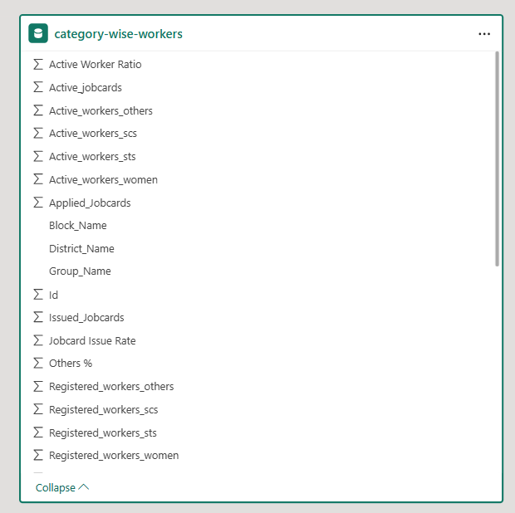

An interactive Power BI dashboard was developed to analyse workforce participation under the Tamil Nadu Job Card system. The dashboard is designed to provide both high-level summaries and detailed drill-down insights across districts, blocks, and groups.
Dashboard Components and Visuals:
- KPI Cards:
  - Total Workers: Displays the total number of registered workers in Tamil Nadu.
  - Total Active Workers: Shows the number of workers actively participating in employment.
  - Job Card Issue Rate (%): Indicates the efficiency of job card issuance compared to applications.
  - Women Participation Rate (%): Highlights the proportion of women workers in the workforce.
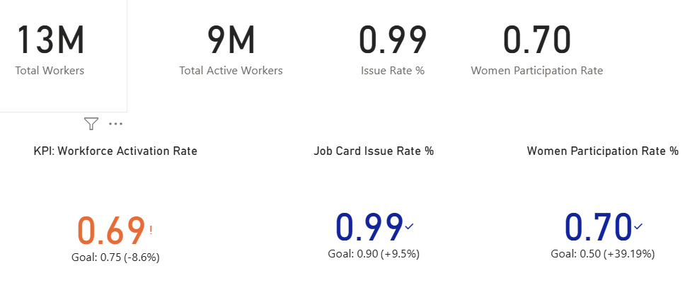
- District-wise Total Registered Workers (Bar Chart): This visual compares the total registered workers across districts, helping identify districts with high and low workforce concentration.
- Active vs Registered Workers by Group (Clustered Column Chart): This chart compares registered workers with active workers at the group level, revealing participation gaps and engagement levels.
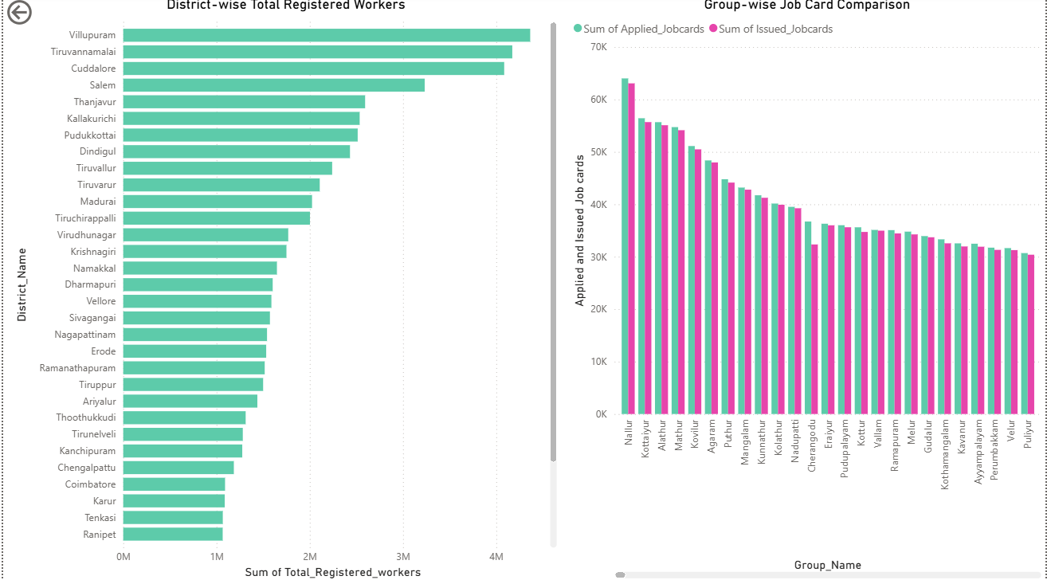
- Job Card Applied vs Issued Comparison: Visualizes the number of job cards applied versus issued, enabling assessment of administrative performance.
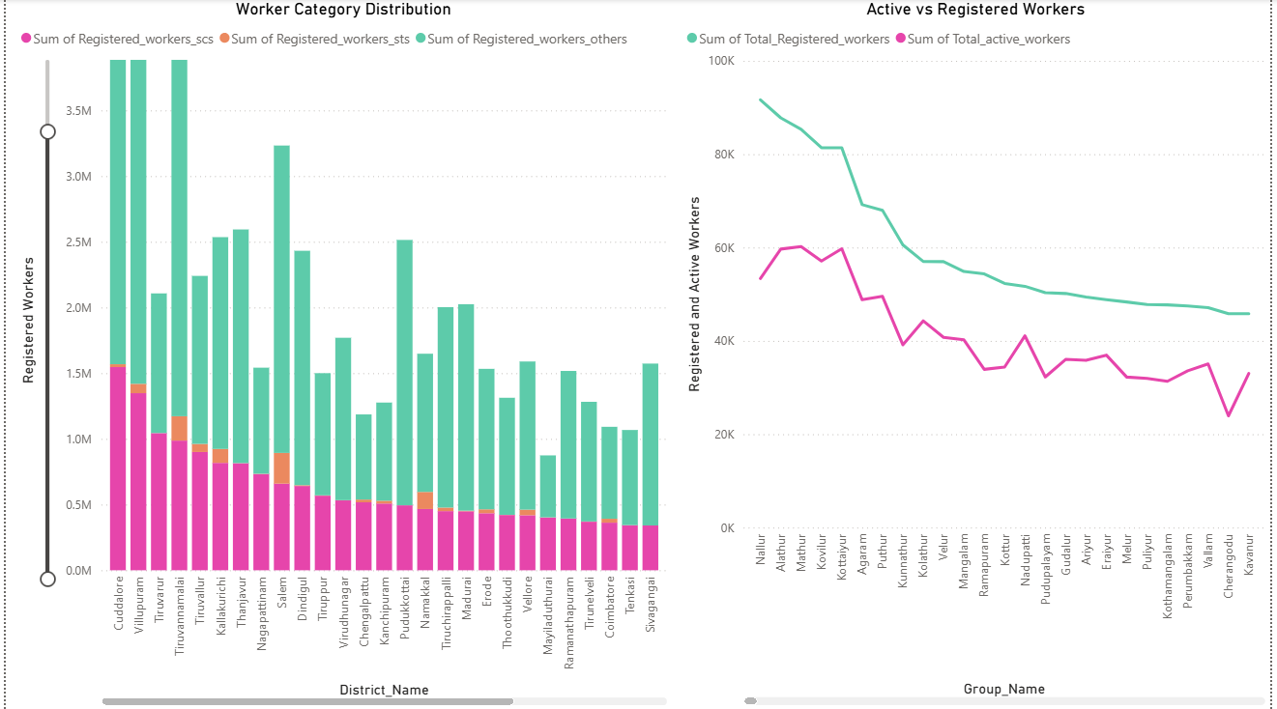
- Registered Workers by Social Category (SC / ST / Others): Shows workforce distribution across social categories, supporting social inclusion analysis.
- Active Workers by Social Category: Highlights active participation among SC, ST, and Other categories across districts.
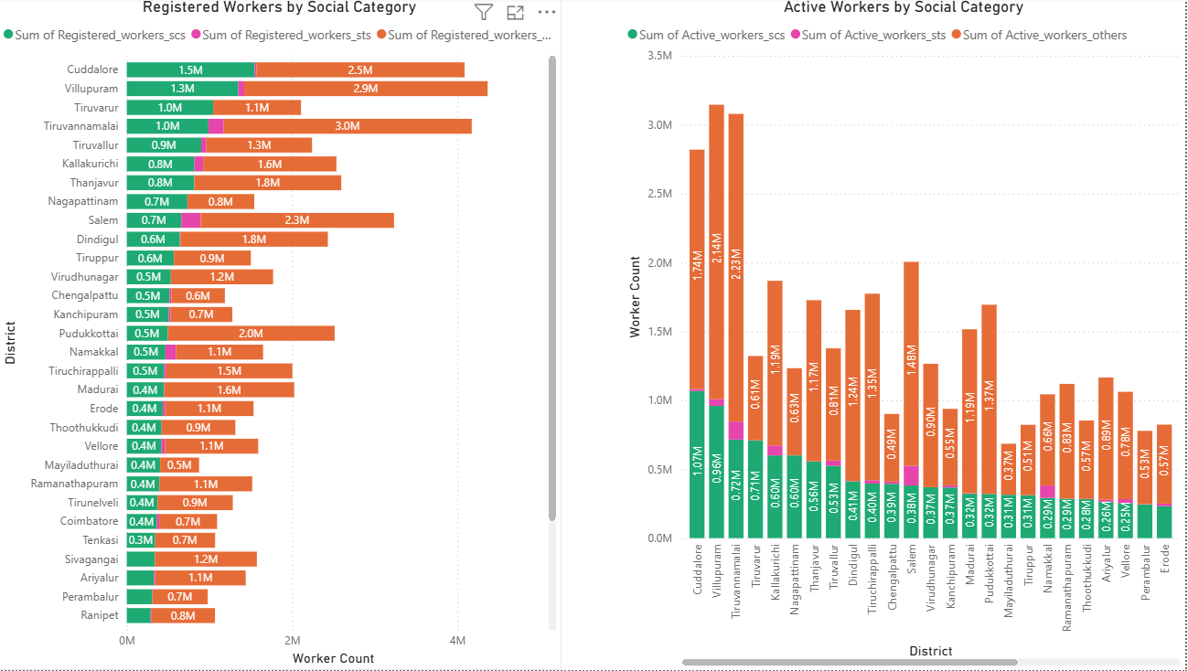
- Women Participation by District: Analyses the contribution of women workers district-wise, emphasizing gender inclusion.
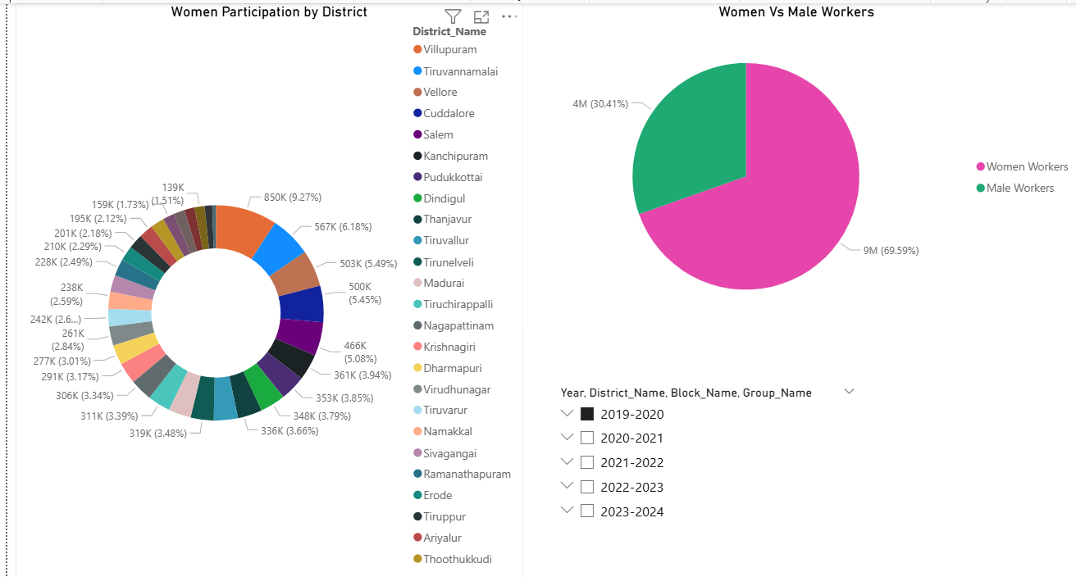
- Hierarchical View (District → Block → Group): Enables drill-down analysis from district level to block and group levels for granular insights.
- Interactive Slicers: Slicers for Year, District, Block, and Group allow dynamic filtering and comparative analysis.
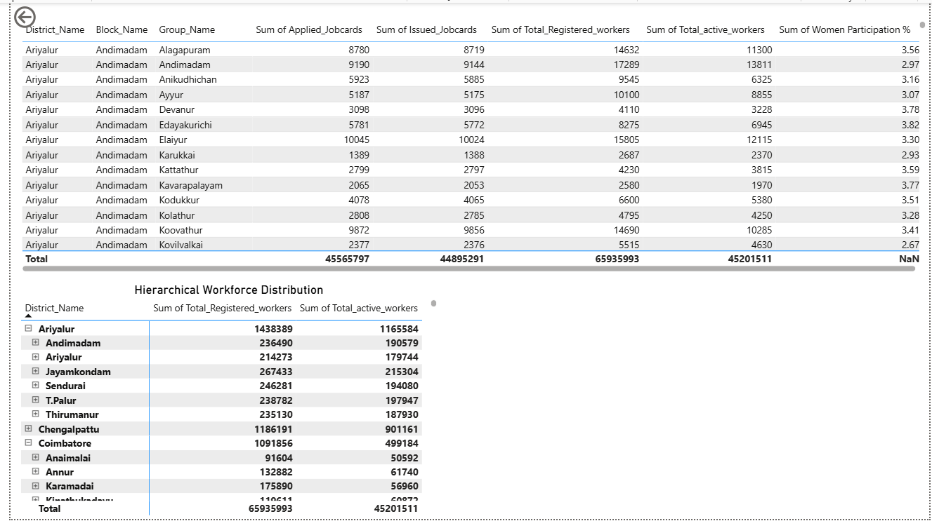

9. Insights and Findings

Descriptive Insights
- Tamil Nadu has 13M registered workers, out of which 9M are active, showing strong workforce engagement.
- Women constitute nearly 70% of the workforce, indicating high female participation in employment programs.

Diagnostic Insights
- Certain districts like Tiruvannamalai, Cuddalore, and Villupuram show higher worker concentration due to population size and rural employment dependency.
- The gap between registered and active workers in some blocks indicates seasonal or availability constraints.

Predictive Insights
- Districts with consistently high activation rates are likely to maintain strong participation in upcoming years.
- Increasing awareness in low-activation blocks can improve workforce utilization.

Prescriptive Insights
- Focused policy intervention is recommended in districts with lower activation rates.
- Special focus on improving participation among underrepresented social categories can enhance inclusiveness.
- Continued support for women workers can further strengthen employment outcomes.

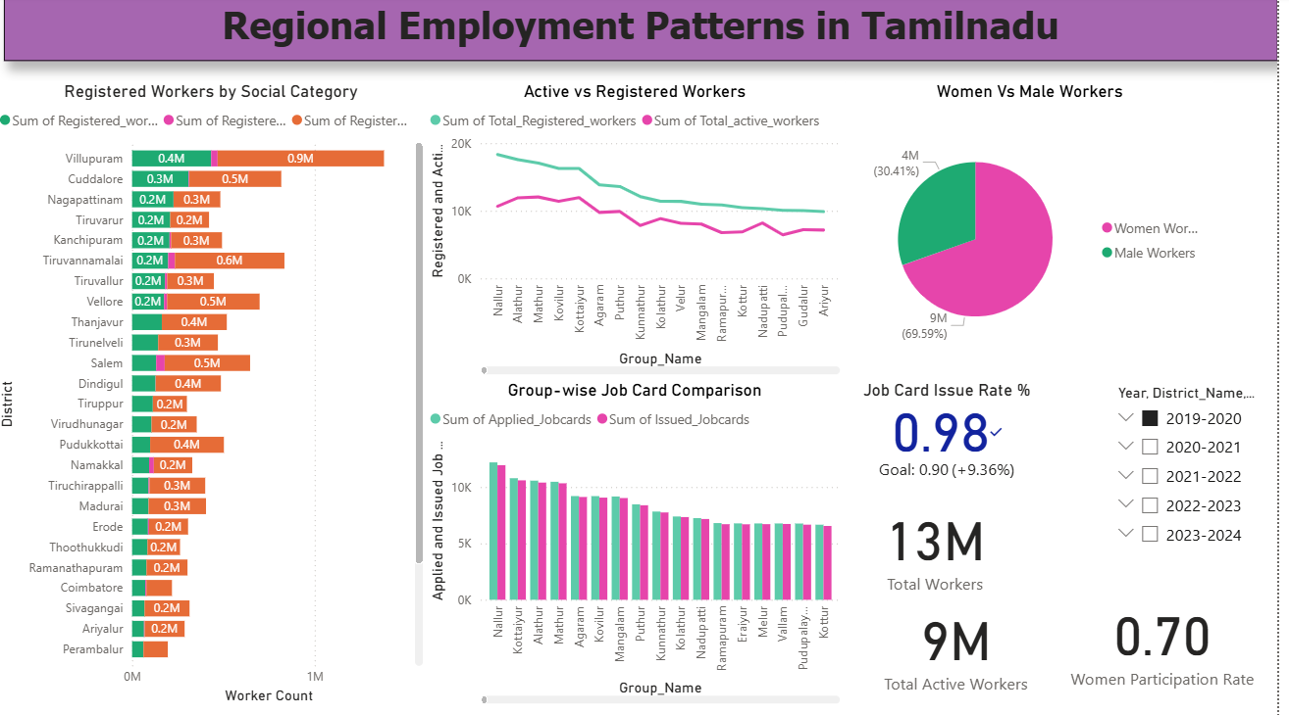

10. Conclusion
This mini project successfully demonstrates the use of Microsoft Excel and Power BI for end-to-end analysis of government employment data. Through systematic data preprocessing, effective data modelling, and interactive visualizations, meaningful insights were derived on workforce participation, job card issuance efficiency, social inclusion, and women empowerment across Tamil Nadu.
The Power BI dashboard enables stakeholders to monitor employment trends, identify regional disparities, and support evidence-based decision-making. The findings from this analysis can assist policymakers and administrators in improving workforce engagement and optimizing employment programs in the state.

